

14th International Conference on
Intelligent Text Processing
and Computational Linguistics
applied for
www.CICLing.org /2013
March 24–30 • Samos, Greece
Cultural program: three days of activities: Ephesus, Samos, nearby islands

anticipated
 |  |  | 
Sophia Ananiadou | Walter Daelemans | Roberto Navigli | Michael Thelwall

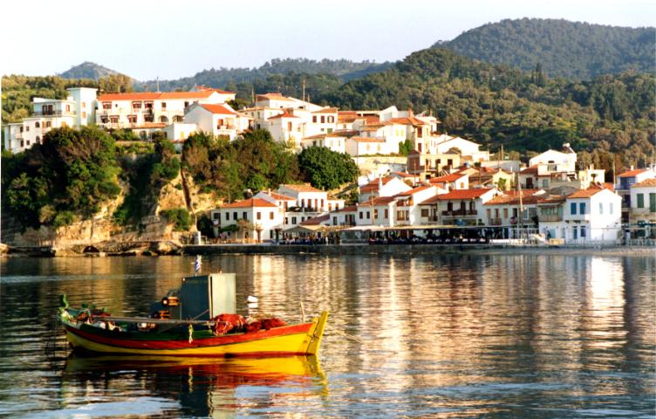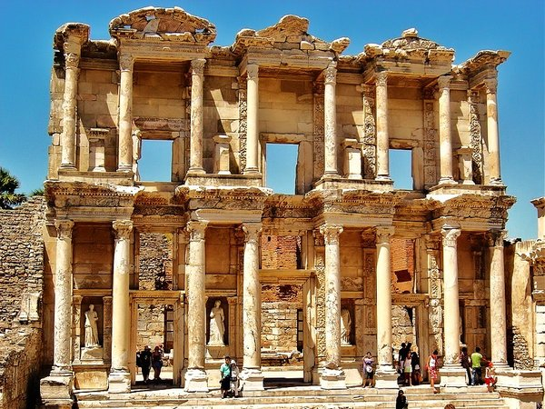

Computational linguistics:  Comp. Linguistics theories and formalisms  Knowledge representation.  Comp. morphology, syntax, semantics  Discourse models. Sentiment analysis  Recognition of textual entailment  Machine translation, text generation  Statistical methods. Lexical resources | Intelligent text processing and applications:  Information retrieval, question answering  Information extraction. Text mining  Document categorization and clustering  Automatic summarization  Natural language interfaces  Spell-checking  and all related topics

