

12th International Conference on
Intelligent Text Processing
and Computational Linguistics
www.CICLing.org /2012
March 11–17 • New Delhi, India
Cultural program: three days of activities: Delhi, Agra & Taj Mahal, Jaipur
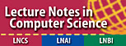

 | 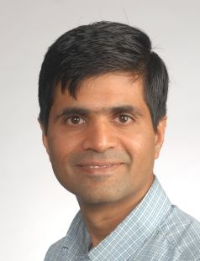 |  |  |  | 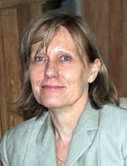 |  | 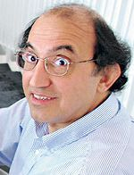
Srinivas Bangalore |  |  | John Carroll |  | Sien Moens | Salim Roukos

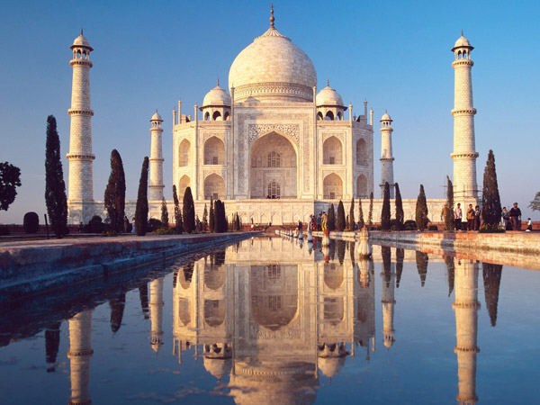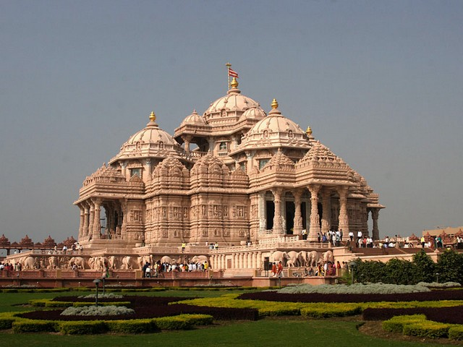

Computational linguistics:  Comp. Linguistics theories and formalisms  Knowledge representation.  Comp. morphology, syntax, semantics  Discourse models  Recognition of textual entailment  Machine translation, text generation  Statistical methods. Lexical resources | Intelligent text processing and applications:  Information retrieval, question answering  Information extraction. Text mining  Document categorization and clustering  Automatic summarization  Natural language interfaces  Spell-checking  and all related topics

