

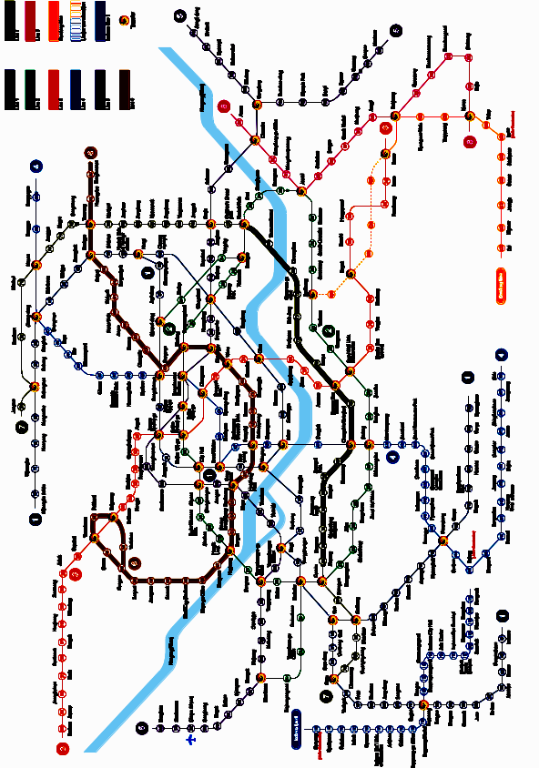
Conf site
Hotel Ibis



Conf site
Conference will be held at Seoul campus of the Chung-Ang University, in the New Engineering College Building (27 on the map), which is behind (and can be also accessed through) the Old Engineering College Building (7 on the map, on the photo), in the Seminar room at the ground floor.

Transportation from the city:
Bus # 1 passes by all three entrances to the campus (22, 23, 24 on the map)
Subway: SangDo station (739, line 7); then on foot or by bus # 1 to the gate 24
Taxi: Chung-Ang University, 221 Huksuk-Dong, Dongjak-Ku (near SangDo)
in Korean: Chung-Ang de-hak-yo,

